CYB 300 Module Two Lab Worksheet Two

Andree Salvo
Southern New Hampshire University
CYB 300
Instructor: Jason Keltner

Lab: Customize or Write Simple Scripts

Exercise 1: Customize or Write Simple Scripts
Prompt | Response
Task 1: Use Standard sh Syntax: Create Scripts Using Conditions and User Interaction: Provide a screenshot of Step 31 showing successful execution of the count script. Add your name to the command line. | 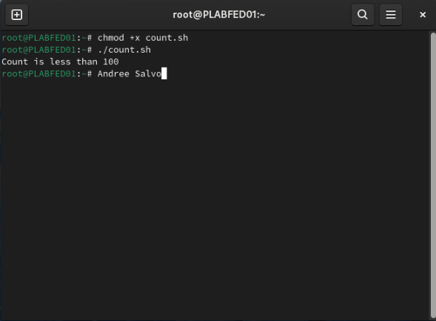
Task 2: Use Command Substitution: Provide a screenshot of Step 5 showing successful execution of the command script. Add your name to the command line. | 